PROJECT REPORT

On

DRIVER DROWSINESS DETECTION in Python

(CSE VI Semester Mini project) 2023-2024



Submitted to: | Submitted by:
Mr. Animesh Shrivastava | Saksham Panwar
(CC-CSE-O-VI-Sem) | Roll. No:2119092  CSE-O-VI-Sem  Session: 2023-2024

DEPARTMENT OF COMPUTER SCIENCE AND INFORMATION TECHNOLOGY

GRAPHIC ERA HILL UNVERSITY, DEHRADUN

CERTIFICATE

Certified that Mr. Saksham Panwar (Roll No.- 2119092) has developed mini project on “Driver’s Drowsiness Detection” for the CS VI Semester Mini Project Lab in Graphic Era Hill University, Dehradun. The project carried out by Students is their own work as best of my knowledge.

Mr Animesh Shrivastava Class Co-ordinator CSE – O – VI – Sem
(CSE Department)
GEHU Dehradun

ACKNOWLEDGEMENT

We wish to express our deep sense of gratitude from the bottom of our heart to our guide Mr Animesh Shrivastava for her motivating discussions, overwhelming suggestions, ingenious encouragement, invaluable supervision, and exemplary guidance throughout this project work.

We thank the management of Graphic Era Hill University for providing us the necessary facilities and support required for the successful completion of the project.

As a final word, we would like to thank everyone who have been a source of support and encouragement and helped us to achieve our goal and complete our project work successfully.

ABSTRACT

Driver fatigue is one of the major causes of accidents in the world. Detecting the drowsiness of the driver is one of the surest ways of measuring driver fatigue. In this project we aim to develop a prototype drowsiness detection system. This system works by monitoring the eyes of the driver and sounding an alarm when he/she is drowsy.
The system so designed is a non-intrusive real-time monitoring system. The priority is on improving the safety of the driver without being obtrusive. In this project the eye blink of the driver is detected. If the drivers’ eyes remain closed for more than a certain period of time, the driver is said to be drowsy, and an alarm is sounded.
In this project, we propose and implement a hardware system which is based on infrared light and can be used in resolving these problems. In the proposed method, following the face detection step, the facial components that are more important and considered as the most effective for drowsiness, are extracted and tracked in video sequence frames. The system has been tested and implemented in a real environment.

Table of Contents

Chapter Description Page No.

No.
Chapter 1 Introduction and Problem Statement 1-4
Chapter 2 Background/ Literature Survey 5-8
Chapter 3 Objectives 9-10
Chapter 4 Hardware and Software Requirements 11-13
Chapter 5 Possible Approach/ Algorithms 14-19
Chapter 6 Project Description 20

Chapter 7 System Design 21-24

Chapter 8 Projects Requires 25

Chapter 9 Modules Description 26-29

Chapter 10 Implementations 30
Chapter 11 Result and Analysis 31-33
Chapter 12 Conclusion and Future Work 34-41
References 42

Chapter 1 Introduction and Problem Statement

In the following sections, a brief introduction and the problem statement for the work has been included.

1.1 Introduction

Driver drowsiness detection is an essential field addressing the peril of drowsy driving, a significant cause of road accidents and fatalities. It aims to use technology to identify and mitigate the dangers associated with fatigued drivers. Drowsy driving is a widespread issue caused by factors like sleep deprivation and circadian rhythm disruptions. Advanced technologies, including computer vision, sensors, and machine learning, play a pivotal role in detecting drowsiness. These systems continuously monitor a driver's behaviour and physiological indicators to issue alerts, enhancing road safety. The driver’s behaviours are noticed in many conditions such as wearing spectacles and also in the dark condition inside the vehicle.
The system is capable of detecting the drowsiness condition within the duration of more than two seconds. After the detection of abnormal behaviours, it is alerted to the driver through alarms and the parking lights will be on that will stop the vehicle which reduces the accidents due to drowsiness of the driver.
Deep learning Architecture detects the face and eyes, based on the status of the eyes. If the eyes are closed more than usual time, it generates an alarm, intimating the driver.
Neglecting our duties towards safer travel has enabled hundreds of thousands of tragedies to get associated with this wonderful invention every year.

In order to monitor and prevent a destructive outcome from such negligence, many researchers have written research papers on driver drowsiness detection systems. But at times, some of the points and observations made by the system are not accurate enough. Hence, to provide data and another perspective on the problem at hand, in order to improve their implementations and to further optimize the solution, this project has been done.

The consequences of drowsy driving can be severe, impairing a driver's alertness and reaction times. Driver drowsiness detection helps prevent accidents and saves lives by recognizing signs of drowsiness early. This field continues to evolve, with innovations integrated into vehicles and wearable devices.
Overall, it's a life-saving endeavour that combines technology and safety to reduce accidents and protect road users worldwide.

1.2 Problem Statement

The problem statement for the present work can be stated as follows:

Driver drowsiness poses a severe threat to road safety, leading to accidents, injuries, and fatalities. Drowsy driving is a pervasive issue caused by factors such as sleep deprivation, long hours of driving, and circadian rhythm disruptions. Recognizing and addressing this problem is critical, as it endangers not only drowsy drivers but also passengers and other road users. The challenge is to develop effective driver drowsiness detection systems that can reliably and accurately identify signs of drowsiness in real- time, enabling timely alerts and interventions.
Current detection methods, though promising, are not yet universally implemented in vehicles, and there is room for improvement in terms of accuracy, adaptability, and user acceptance. Achieving a balance between timely alerts and minimizing false alarms is a complex challenge. Moreover, integrating these systems seamlessly into vehicles and ensuring their affordability remains a hurdle.
This problem statement calls for continued research and innovation to enhance driver drowsiness detection systems, make them more accessible, and ultimately contribute to the reduction of drowsy driving-related accidents and fatalities on our roads.
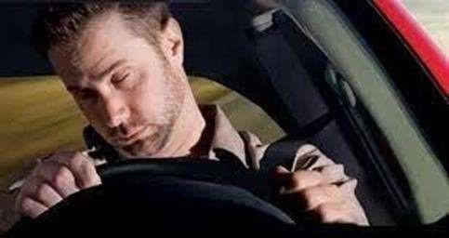
Fig.1.Driver drowsiness

1.3 Motivation
Witnessing accidents
Bringing awareness
Taking advantage of Technology.
Bringing up Suitable Software.
Include the Software into convenience.
Looking for updating the versions.

1.4 Goal and Objectives

There are many products out there that provide the measure of fatigue level in the drivers which are implemented in many vehicles. Also, it alerts the user on reaching a certain saturation point of the drowsiness measure.

1.5 SCOPE

This project can be implemented in the form of mobile application to reduce the cost of hardware. This project can be integrated with car, so that automatic speed control can be imparted if the driver is found sleeping.

Chapter 2

Background/ Literature Survey
Driver drowsiness detection is an area of paramount importance, primarily due to the pervasive issue of drowsy driving, which is known to contribute significantly to road accidents and fatalities. In the past, early drowsiness detection efforts primarily relied on observing behavioural indicators like yawning and head nodding, which, although valuable, had limitations in terms of accuracy and adaptability.

However, the landscape has evolved rapidly with the advent of advanced technologies. These include computer vision systems that can analyse facial features such as eye closure and gaze direction to identify signs of drowsiness. Infrared sensors have been developed to monitor a driver's facial temperature, providing insights into their state of alertness.

Beyond behavioural cues, some systems incorporate physiological measures like electroencephalography (EEG), electrooculography (EOG), and electrocardiography (ECG) to monitor brain activity, eye movements, and heart rate. These measures offer more objective indicators of drowsiness, enhancing the accuracy of detection.

A pivotal factor in the advancement of drowsiness detection systems is the integration of machine learning and artificial intelligence. These technologies enable systems to learn and adapt to the specific behaviour of individual drivers, providing more accurate and personalized
alerts.

Automakers are increasingly focused on integrating drowsiness detection systems into vehicles, with the ability to issue timely warnings, such as audible alarms and haptic feedback, when signs of drowsiness are detected. This integration not only improves real-time safety but also highlights the growing commitment of the automotive industry to address this critical issue.

Challenges, however, persist. Striking a balance between timely alerts and minimizing false alarms is complex. Ensuring user acceptance and seamlessly integrating these technologies into vehicles without inflating costs are ongoing challenges. Government regulations and public awareness campaigns are promoting the development and adoption of driver drowsiness detection systems, further emphasizing their significance.

Recent research highlights the real-world impact of drowsiness detection systems, with evidence showing substantial reductions in the number of accidents and fatalities attributed to drowsy driving. These findings underscore the critical role these technologies play in improving road safety and saving lives by preventing accidents caused by drowsy driving. The literature surveyed here forms the foundation for understanding the current state of this field and its potential for continued advancements in the future.

2.1 INTRODUCTION

This survey is done to comprehend the need and prerequisite of the general population, and to do as such, we went through different sites and applications and looked for the fundamental data. Based on these data, we made an audit that helped us get new thoughts and make different arrangements for our task. We reached the decision that there is a need of such application and felt that there is a decent extent of progress in this field too.
There are some research on Driver’s Drowsiness Detection, for the proper outcome of the subject and usage of it. The researches use different approaches for the application and the requirement processes.
Drowsiness Detection Based On Driver Temporal Behaviour(31-March 2021, F. Faraji, F. Lotfi, J. Khorramdel, A. Najafi, A. Ghaffari). In this research YOLOv3 CNN is applied as a pretrained network, which is proved to be utilized as a powerful means for object detection.LSTM (Long-Short Term Memory) neural network is employed to learn driver temporal behaviors including yawning and blinking time period as well as sequence classification. One of the main factors of the temporal behavior is that the driver becomes gradually diverted from the road and road traffic. Hence detection is not always accurate.

A Survey on State of The Art Driver Drowsiness Detection Techniques(1st December 2020, FHikmat Ullah Khan).The detection system includes the processes of face image
extraction, yawning tendency, blink of eyes detection, eye area extraction etc. The percentage
of the eyelid closure of the algorithms over the pupil over time is relatively very low.

Driver Drowsiness Detection(21-09-2020, V B Navya Kiran, Raksha R, Anisoor Rahman, Varsha K N, Dr. Nagamani N P).The detection system includes the processes of face image extraction, yawning tendency, blink of eyes detection, eye area extraction etc. This paper provides a comparative study on papers related to driver drowsiness detection and alert system. It is designed in such a way where system does not continuously record or retain any data.

Driver Drowsiness Detection System(12 December 2019, Pratyush Agarwal)
This paper analyses the method used to detect driver’s drowsiness and proposes the results & solutions on the limited implementation of the various techniques that are used in such embedded systems.

Driver Drowsiness Detection System(May 2019,Muhammad Faique Shakeel and Nabita
Bajwa). In this article, they propose a novel deep learning methodology based on
Convolutional Neural Networks (CNN) to tackle the Project. In the trained model, we only use 250 low-light images.

A Survey on Driver Drowsiness Detection Techniques(01 December 2020, Reshma , Ishwarya and Sai Vennala). Drowsiness Detection System, the detection system includes the processes of face image extraction, yawning tendency, blink of eyes etc.

2.2 SUMMARY
In this Python project, we have built a drowsy driver alert system that you can implement in numerous ways. We used OpenCV to detect faces and eyes using a haar cascade classifier and then we used a
CNN model to predict the statu

Chapter 3

Objectives

The objectives of the proposed work are as follows:

- Enhance Road Safety: The primary objective of driver drowsiness detection is to improve road safety by preventing accidents and reducing fatalities caused by drowsy driving.

- Early Detection: Develop systems that can identify signs of drowsiness in real-time, providing timely alerts to drivers before they become a safety risk.

- Reduce Accidents: Decrease the number of accidents attributed to drowsy driving, thus minimizing injuries and fatalities on the road.

- Personalization: Create adaptive systems that can tailor alerts based on individual driver behavior and physiological indicators to minimize false alarms and maximize effectiveness.

- Technology Integration: Integrate drowsiness detection technologies seamlessly into vehicles, making them an integral part of automotive safety features.

- User Acceptance: Ensure that drowsiness detection systems are user-friendly and well- accepted by drivers to encourage their adoption.
- Cost-Efficiency: Develop cost-effective solutions that can be readily implemented in a wide range of vehicles, making road safety accessible to all.

- Awareness and Advocacy: Raise awareness about the dangers of drowsy driving and advocate for the adoption of drowsiness detection systems through government policies, regulations, and public education.

- Continual Innovation: Encourage ongoing research and innovation in the field to refine and enhance the accuracy and reliability of drowsiness detection technologies.

- Global Impact: Extend the reach and adoption of these systems on a global scale to protect road users in different regions and under diverse driving conditions.
Chapter 4

Hardware and Software Requirements
4.1 Hardware Requirements:

- Camera System: Most modern driver drowsiness detection systems rely on camera sensors, so a high-quality camera system is essential. This typically includes a small, unobtrusive camera mounted inside the vehicle, pointed towards the driver's face.

- Infrared Sensors: Infrared sensors may be required for nighttime or low-light detection.

These sensors can monitor changes in the driver's facial temperature, aiding in drowsiness detection.

- Physiological Sensors (Optional): Some advanced systems incorporate physiological sensors, such as EEG electrodes, EOG sensors, or ECG sensors, to monitor brain activity, eye movements, or heart rate. The hardware for these sensors should be compatible with the chosen system.

- Microcontroller/Processor: A robust microcontroller or processor is needed to process image data and run the drowsiness detection algorithms. This could be a dedicated hardware component or a high-performance computer, depending on the system's complexity.
- Audio System (Optional): If the system issues audible warnings or alerts, a functioning audio system is necessary.

- Haptic Feedback (Optional): For systems that provide tactile feedback to the driver, haptic actuators or vibration mechanisms are required.

- Wiring and Power Supply: Adequate wiring and power supply are needed to connect and operate the various hardware components within the vehicle.

4.2 Software Requirements:

- Drowsiness Detection Algorithms: The software should include specialized algorithms for detecting drowsiness based on the data collected from the hardware components. These algorithms can range from simple rule-based systems to complex machine learning models.

- Image Processing Software: To analyze and process the video feed from the camera, image processing software is essential. This software extracts features from the driver's face, such as eye closure and head position.

- Machine Learning Framework (if applicable): If machine learning is employed, software for training and deploying machine learning models is necessary. This may include frameworks like TensorFlow, PyTorch , or OpenCV for computer vision tasks.
- Alert System: Software to generate and issue alerts to the driver when drowsiness is detected.

This may involve audio alerts, visual warnings on the dashboard, or haptic feedback.

- User Interface (UI): For systems with user displays or control interfaces, a user-friendly interface for configuring and interacting with the drowsiness detection system is required.

- Data Logging and Storage: Systems may include software for logging and storing drowsiness-related data, which can be useful for analysis and reporting.

- Operating System: The software should be compatible with the vehicle's operating system or, in the case of standalone devices, the appropriate operating system (e.g., Linux, Android, or embedded systems).

- Integration with Vehicle Systems (if applicable): In some cases, integration with the vehicle's onboard systems, such as the Engine Control Unit (ECU), may be required for more advanced functionalities.

- Data Transmission (if cloud-based): If the system relies on cloud-based or remote monitoring, software for data transmission and commune.

Chapter 5

Possible Approaches and Algorithms for Driver Drowsiness Detection:

- Computer Vision-Based Approaches:

  - Eye Closure Detection: Monitor the driver's eyes to detect prolonged eye closure or slow blink patterns. Algorithms like Haar cascades and HOG-SVM (Histogram of Oriented Gradients - Support Vector Machines) can be used for this purpose.
  - Facial Landmark Detection: Utilize facial landmark detection to track features like eye and mouth movement. Algorithms such as dlib and OpenCV can be applied for accurate facial landmark localization.
  - Convolutional Neural Networks (CNNs): Train CNNs to analyze facial images in real-time and detect signs of drowsiness based on features like eye openness, head pose, and facial expressions.

- Infrared-Based Approaches:

  - Monitoring Facial Temperature: Infrared sensors can track changes in facial temperature, as drowsiness may lead to subtle variations. Algorithms analyze these thermal patterns to infer drowsiness.

- Physiological-Based Approaches:

  - Electroencephalography (EEG): EEG sensors measure brain activity and can detect drowsiness-related changes in brainwave patterns. Signal processing and machine learning techniques can be used to analyze EEG data.
  - Electrooculography (EOG): EOG sensors monitor eye movements, and algorithms can detect slow or heavy eye movements that are indicative of drowsiness. _{o} Electrocardiography (ECG): ECG sensors measure heart rate and heart rate variability. Variations in these signals can indicate changes in the driver's physiological state related to drowsiness.

- Machine Learning-Based Approaches:

  - Supervised Learning: Train machine learning models (e.g., Support Vector Machines, Random Forests, or Neural Networks) using labeled data to classify driver states as alert or drowsy based on features extracted from the sensors. o Deep Learning: Utilize deep learning techniques, such as Convolutional Neural Networks (CNNs) or Recurrent Neural Networks (RNNs), to create more robust and accurate models for drowsiness detection, especially when dealing with image and sensor data.
- Fusion of Multiple Sensors:
o Combine data from different sensors (e.g., cameras, infrared, and physiological sensors) to create a comprehensive driver monitoring system. Fusion techniques like feature-level fusion or decision-level fusion can be employed.

- Real-Time Monitoring and Alert Systems:
o Develop algorithms for real-time monitoring and alert generation. This includes setting thresholds for drowsiness indicators and generating timely alerts through auditory, visual, or haptic feedback.

- User-Specific Models:

  - Personalize drowsiness detection by creating user-specific models that adapt to individual driver behavior and variations in physiological responses.

- Data-Driven Approaches:
- Use large datasets of driver behavior, both alert and drowsy, to train and validate models. Collect and label data in real-world driving scenarios to improve model accuracy.

9. Cloud-Based Monitoring:

- Implement cloud-based solutions to enable remote monitoring and data analysis, providing insights into driver behavior over time.
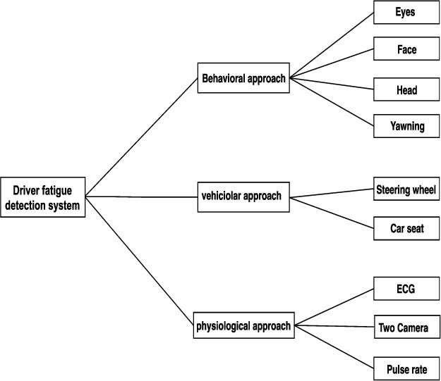

Fig. Possible Approaches and Algorithms for Driver Drowsiness Detection.

LITERATURE REVIEW

INTRODUCTION

This survey is done to comprehend the need and prerequisite of the general population, and to do as such, we went through different sites and applications and looked for the fundamental data. Based on these data, we made an audit that helped us get new thoughts and make different arrangements for our task. We reached the decision that there is a need of such application and felt that there is a decent extent of progress in this field too.
There are some research on Driver’s Drowsiness Detection, for the proper outcome of the subject and usage of it. The researches use different approaches for the application and the requirement processes.

Drowsiness Detection Based On Driver Temporal Behaviour(31-March 2021, F. Faraji, F. Lotfi, J. Khorramdel, A. Najafi, A. Ghaffari). In this research YOLOv3 CNN is applied as a pretrained network, which is proved to be utilized as a powerful means for object detection.LSTM (Long-Short Term Memory) neural network is employed to learn driver temporal behaviors including yawning and blinking time period as well as sequence classification. One of the main factors of the temporal behavior is that the driver becomes gradually diverted from the road and road traffic. Hence detection is not always accurate.

A Survey on State of The Art Driver Drowsiness Detection Techniques(1st December 2020, FHikmat Ullah Khan).The detection system includes the processes of face image
extraction, yawning tendency, blink of eyes detection, eye area extraction etc. The percentage
of the eyelid closure of the algorithms over the pupil over time is relatively very low.

Driver Drowsiness Detection(21-09-2020, V B Navya Kiran, Raksha R, Anisoor Rahman, Varsha K N, Dr. Nagamani N P).The detection system includes the processes of face image extraction, yawning tendency, blink of eyes detection, eye area extraction etc. This paper provides a comparative study on papers related to driver drowsiness detection
and alert system. It is designed in such a way where system does not continuously record or retain
any data.

Driver Drowsiness Detection System(12 December 2019, Pratyush Agarwal)
This paper analyses the method used to detect driver’s drowsiness and proposes the results & solutions on the limited implementation of the various techniques that are used in such embedded systems.

Driver Drowsiness Detection System(May 2019,Muhammad Faique Shakeel and
Nabita Bajwa). In this article, they propose a novel deep learning methodology based on
Convolutional Neural Networks (CNN) to tackle the Project. In the trained model, we only use 250 low- light images.
A Survey on Driver Drowsiness Detection Techniques(01 December 2020, Reshma , Ishwarya and Sai Vennala). Drowsiness Detection System, the detection system includes the processes of face image extraction, yawning tendency, blink of eyes etc.

SUMMARY
In this Python project, we have built a drowsy driver alert system that you can implement in numerous ways. We used OpenCV to detect faces and eyes using a haar cascade classifier and then we used a CNN model to predict the status.

CHAPTER 6

PROJECT DESCRIPTION
- EXISTING SYSTEM AND DISADVANTAGES Vision based techniques:
NO EYE DETECTION – most critical sign of drowsiness Yawning and nodding are not always practical.
Varies from person to person – some may not yawn when they are sleepy sometimes.
Physiological sensors:
More accurate solutions
Needs to be attached to the human body - If driver forgets to wear it?
  - May hesitate to wear
Easy wear biosensors are developed.
  - Head bands, headphones (Signal-Channel EEG)
  - Portal glasses for EOG
  - Hand bands for PPG
6.1 PROPOSED SYSTEM AND ADVANTAGES
The proposed system will be continuously monitoring the movement of the driver’s eye by a live camera and all the monitored signals are pre - processed. In order to overcome drawbacks, Python is used in which the trained system is already installed and avoids the time to process that occurs from the scratch.
A Black Box with the software installed is used to detect the driver drowsiness and alerts the driver with buzzer, if driver is affected by drowsiness.

CHAPTER 7

SYSTEM DESIGN

7. SYSTEM ARCHITECTURE

The model we used is built with Keras using Convolutional Neural Networks (CNN). A convolutional neural network is a special type of deep neural network which performs extremely well for image classification purposes. A CNN basically consists of an input layer, an output layer and a hidden layer which can have multiple numbers of layers. A convolution operation is performed on these layers using a filter that performs 2D matrix multiplication on the layer and filter. The CNN model architecture consists of the following layers:

  - Convolutional layer; 32 nodes, kernel size 3
  - Convolutional layer; 32 nodes, kernel size 3
  - Convolutional layer; 64 nodes, kernel size 3
  - Fully connected layer; 128 nodes

The final layer is also a fully connected layer with 2 nodes. In all the layers, a Relu activation function is used except the output layer in which we used Softmax.

Python Project on Steps for Performing Driver Drowsiness Detection
Download the Python project source code from the zip and extract the files in your system:
Python Project Zip File

The contents of the zip are:
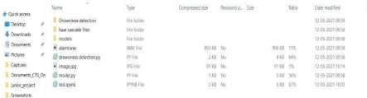
Fig. Table 4.1

  - The “haar cascade files” folder consists of the xml files that are needed to detect objects from the image. In our case, we are detecting the face and eyes of the person.
  - The models folder contains our model file “cnnCat2.h5” which was trained on convolutional neural networks.
  - We have an audio clip “alarm.wav” which is played when the person is feeling drowsy.

  - “Model.py” file contains the program through which we built our classification model by training on our dataset. You could see the implementation of convolutional neural network in this file.
  - “Drowsiness detection.py” is the main file of our project. To start the detection procedure, we have to run this file.

4.2 BLOCK DIAGRAM
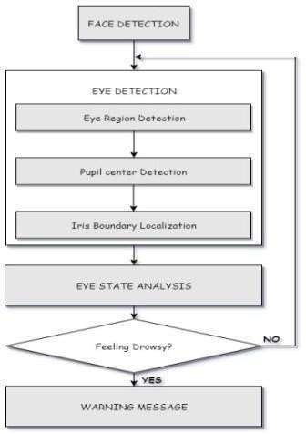
Fig 4.2
The system will be continuously monitoring the movement of the driver’s eye by a live camera and all the monitored signals are pre - processed. A Black Box with the software installed is used to detect the driver drowsiness and alerts the driver with buzzer.

4.2 USE CASE DIAGRAM
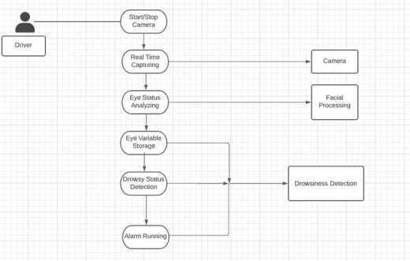

Fig. 4.3

Drowsiness detection is a safety technology that can prevent accidents that are caused by drivers who fell asleep while driving. The project is to build a drowsiness detection system that will detect that a person’s eyes are closed for a few seconds. This system will alert the driver when drowsiness is detected. In this Python project, we will be using OpenCV for gathering the images from webcam and feed them into Deep Learning a model which will classify whether the person’s eyes are ‘Open’ or ‘Closed’.

CHAPTER 8

PROJECT REQUIRES

8.1Software Requirements

Python: Python is the basis of the program that we wrote. It utilizes many of the python libraries. Python 3
Libraries: Numpy
Tensorflow opencv, keras Pygame.
Operating System:
Windows

8.1 Hardware Requirements
Laptop with basic hardware
Webcam

CHAPTER 9

MODULES DESCRIPTION

Webcam Capturing Face and
Eye Detection
Drowsiness Detection (with Alert Message and Alarm Sound)

9.1 MODULE: 1

With a webcam, we will take images as input. So to access the webcam, we made an infinite loop that will capture each frame. We use the method provided by OpenCV, cv2.VideoCapture(0) to access the camera and set the capture object (cap). cap.read() will read each frame and we store the image in a frame variable

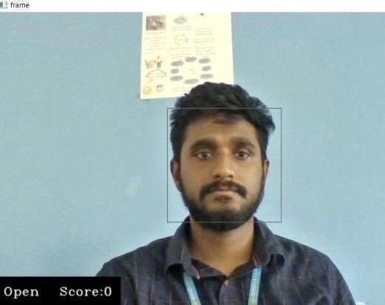
Fig. 6.1
Camera appears and starts to capture the image

9.2 MODULE: 2
Face and eye detection:
▪ The “haar cascade files” folder consists of the xml files that are needed to detect objects from the image (in machine learning). In our case, we are detecting the face and eyes of the person.
▪ To detect the face in the image, we need to first convert the image into grayscale as the OpenCV algorithm for object detection takes gray images in the input. We don’t need colour information to detect the objects. We will be using haar cascade classifier to detect faces. This line is used to set our classifier.
▪ The cascades themselves are just a bunch of XML files that contain OpenCV data used to detect objects. You initialize your code with the cascade you want, and then it does the work for you.
▪ It loads face cascade into memory and read the mage and convert into grayscale.

(many operations are done in grayscale as we need not define Green , Red and Blue colours here) Haar cascade approach:

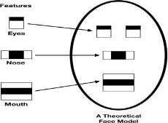

Fig 6.2
Theoretical Face Model for Classification

9.3 MODULE 3:

Drowsiness Detection
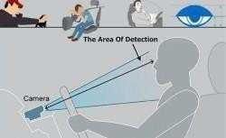

Fig. 6.3

▪ The value we will use to determine how long the person has closed his eyes is threshold value. So, if both eyes are
closed, we will keep on increasing score and when eyes are
open, we decrease the score. We are drawing the result on the screen
using cv2.putText() function which will display real time status of the person.

▪ A threshold is defined for example if score becomes greater than 15 that means the person’s
eyes are closed for a long period of time. This is when we beep the alarm using
sound.play().
▪ All three of us worked on code

CHAPTER 10

IMPLEMENTATION
- Take image as input from a camera.
- Detect the face in the image and create a Region of Interest(ROI).
- Detect the eyes from ROI and feed it to the classifier.
- Classifier will categorize whether eyes are open or closed.
- Calculate score to check whether the person is drowsy.

First we have used a camera which is setup at desirable position in a car that looks for faces stream.
If face gets detected, the facial landmark detection task is applied and region of eyes is extracted.
Once we get the eye region, we calculate the Eye Aspect Ratio to find out if the eye-lids are down for a substantial amount of time.
On the off chance that the Eye Aspect Ratio demonstrates that the eyes are shut for a considerably long measure of time, the alert will sound noisy to wake the driver up.For the functionalities of the system and to make it work efficiently we have used OpenCv, dlib and Python. The implementation of the drowsiness detector system includes machine learning algorithms which are in turn included in OpenCv ML algorithms. There are numerous ML algorithms but for our purpose we required only the face detector algorithm. It works efficiently well overall. It can also be used to detect various different types of objects with the required software

CHAPTER 11

RESULT AND ANALYSIS

RESULT:

In this Python project, we have built a drowsy driver alert system that you can implement in numerous ways. We used OpenCV to detect faces and eyes using a haar cascade classifier and then we used a CNN model to predict the status.

ANALYSIS:

Opened Eyes Detection:

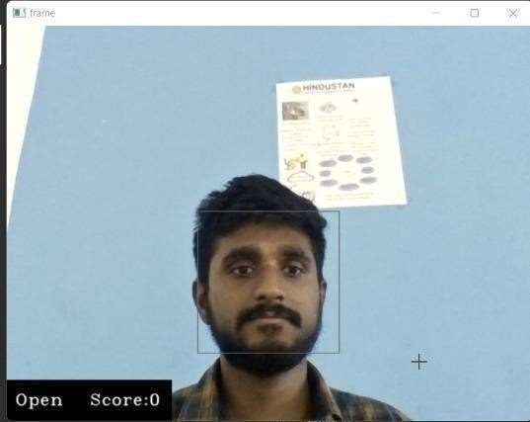
Fig 8.1 (a)
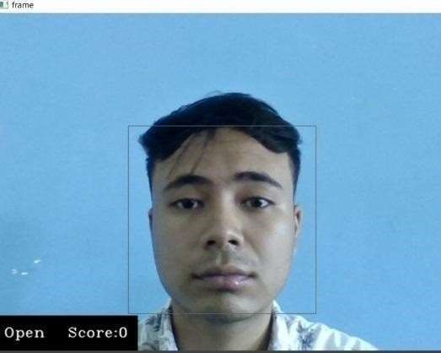

Fig 8.1 (b)

Closed Eyes

Detection : Sleep

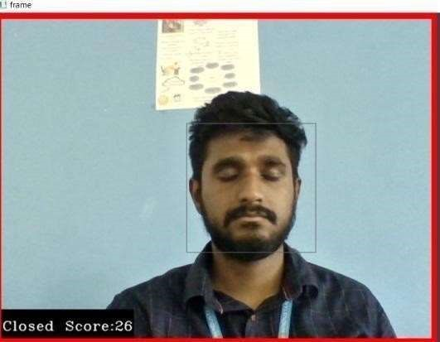
Alert :
Fig 8.1 (c)
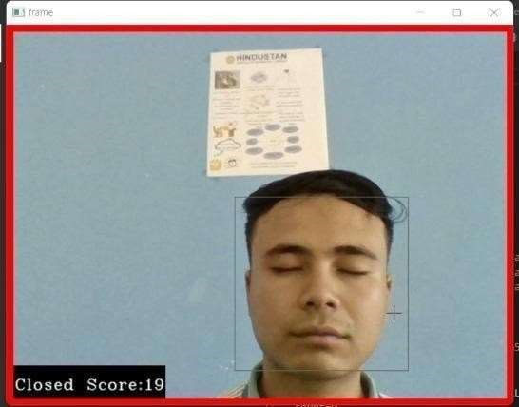

Fig 8.1 (d)
CHAPTER 12

CONCLUSION AND FUTURE WORK

CONCLUSION:
It completely meets the objectives and requirements of the system. The framework has achieved an unfaltering state where all the bugs have been disposed of. The framework cognizant clients who are familiar with the framework and comprehend it's focal points and the fact that it takes care of the issue of stressing out for individuals having fatigue-related issues to inform them about the drowsiness level while driving.
The ultimate goal of the system is to check the drowsiness condition of the driver. Based on the eye movements of the driver, the drowsiness is detected and according to eye blink, the alarm will be generated to alert the driver and to reduce the speed of the vehicle along with the indication of parking light. By doing this, many accidents will be reduced and provides safety to the driver and vehicle. A system that is driver safety and car security is presented only in luxurious costly cars. Using eye detection, driver security and safety can be implemented in normal car also.

FUTURE WORK:
The model can be improved incrementally by using other parameters like blink rate, yawning, state of the car, etc. If all these parameters are used it can improve the accuracy by a lot.
We plan to further work on the project by adding a sensor to track the heart rate in order to prevent accidents caused due to sudden heart attacks to drivers.
Same model and techniques can be used for various other uses like Netflix and other streaming services can detect when the user is asleep and stop the video accordingly. It can also be used in application that prevents user from sleeping.

APPENDIX A: SAMPLE SCREEN SHOTS

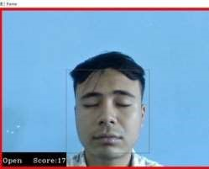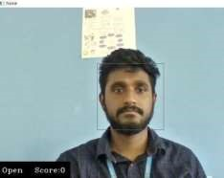

APPENDIX B: SAMPLE CODE
DETECTION : (detection.py) import cv2 import os from keras.models import load_model import numpy as np from pygame import mixer import time
import tensorflow as tf

mixer.init() print(os.getcwd()) sound = mixer.Sound('alarm.wav')
face = cv2.CascadeClassifier('haar cascade files\haarcascade_frontalface_alt.xml') leye = cv2.CascadeClassifier('haar cascade files\haarcascade_lefteye_2splits.xml') reye = cv2.CascadeClassifier('haar cascade files\haarcascade_righteye_2splits.xml')
lbl=['Close','Open']

model = load_model('models/cnnCat2.h5') path
= os.getcwd() cap = cv2.VideoCapture(0)
font = cv2.FONT_HERSHEY_COMPLEX_SMALL count=0 score=0
thicc=2 rpred=[99] lpred=[99]

while(True):
ret, frame = cap.read() height,width = frame.shape[:2]

gray = cv2.cvtColor(frame, cv2.COLOR_BGR2GRAY) for (x,y,w,h) in faces: cv2.rectangle(frame, (x,y) , (x+w,y+h) , (100,100,100) ,1 except: # isplaying = False pass
if(thicc<16):
thicc= thicc+2
else:
thicc=thicc-2 if(thicc<2):
thicc=2 cv2.rectangle(frame,(0,0),(width,height),(0,0,255),thicc)
cv2.imshow('frame',frame) if cv2.waitKey(1) & 0xFF == ord('q'): break
cap.release() cv2.destroyAllWindows()

TEST: (test.ipynb)
{
"metadata": {
"language_info": {
"codemirror_mode": {
"name": "ipython", "version":
3
},
"file_extension": ".py", "mimetype":
"text/x-python", "name": "python",
"nbconvert_exporter": "python",
"pygments_lexer": "ipython3",
"version": "3.7.10"
},
"orig_nbformat": 2,
"kernelspec": { "name":
"python3710jvsc74a57bd0fd034ed54560f0698c2946b7ca675e493afbd7ee3c0ecf162a e3deac3cf4477b",
"display_name": "Python 3.7.10 64-bit ('pytorch': conda)" }
},
"nbformat": 4,
"nbformat_minor": 2,
"cells": [
{
"cell_type": "code",
" for (x,y,w,h) in faces:\n",
" cv2.rectangle(frame, (x,y) , (x+w,y+h) , (100,100,100) ,1)\n", "\n",
" if(rpred[0]==0):\n", " lbl='Closed'\n",
" break\n", "\n",
" for (x,y,w,h) in left_eye:\n",
" l_eye=frame[y:y+h,x:x+w]\n"," count=count+1\n",
" l_eye =
cv2.cvtColor(l_eye,cv2.COLOR_BGR2GRAY)\n", " l_eye
= cv2.resize(l_eye,(24,24))\n", " l_eye= l_eye/255\n",
" l_eye=l_eye.reshape(24,24,-1)\n",
" l_eye = np.expand_dims(l_eye,axis=0)\n", " lpred = model.predict_classes(l_eye)\n",
" if(lpred[0]==1):\n", " lbl='Open'\n",
" if(lpred[0]==0):\n"," lbl='Closed'\n", " break\n",
"\n",
{
"cell_type": "code",
"execution_count": null,
"metadata": {},
"outputs": [],
"source": [] MODEL : (Model.py) import os from keras.preprocessing import image import matplotlib.pyplot as plt import numpy as np from keras.utils.np_utils import to_categorical import random,shutil from keras.models import Sequential from keras.layers import Dropout,Conv2D,Flatten,Dense, MaxPooling2D, BatchNormalization from keras.models import load_model

def generator(dir, gen=image.ImageDataGenerator(rescale=1./255), shuffle=True,batch_size=1,target_size=(24,24),class_mode='categorical'
):

return gen.flow_from_directory(dir,batch_size=batch_size,shuffle=shuffle,color_mode='gra
yscale',class_mode=class_mode,target_size=target_size)

BS= 32 TS=(24,24) train_batch= generator('data/train',shuffle=True, batch_size=BS,target_size=TS) valid_batch= generator('data/valid',shuffle=True, batch_size=BS,target_size=TS) SPE= len(train_batch.classes)//BS VS = len(valid_batch.classes)//BS

print(SPE,VS)

# img,labels= next(train_batch) # print(img.shape)

model = Sequential([
Conv2D(32, kernel_size=(3, 3), activation='relu', input_shape=(24,24,1)),
MaxPooling2D(pool_size=(1,1)),
Conv2D(32,(3,3),activation='relu'), MaxPooling2D(pool_size=(1,1)),
#32 convolution filters used each of size 3x3 #again
Conv2D(64, (3, 3), activation='relu'), MaxPooling2D(pool_size=(1,1)),

#output a softmax to squash the matrix into output probabilities Dense(2, activation='softmax')
])

model.compile(optimizer='adam',loss='categorical_crossentropy',metrics=['accuracy']
)
model.fit_generator(train_batch,

REFERENCES:
▪ COMPUTATIONALLY EFFICIENT FACE DETECTION; B.
SCHLKOPF-A. BLAKE, S. ROMDHANI, AND P. TORR.
▪ USE OF THE HOUGH TRANSFORMATION TO DETECT LINES AND CURVES IN PICTURE; R. DUDA AND P. E. HART.
▪ JAIN, “FACE DETECTION IN COLOR IMAGES; R. L.
HSU, M. ABDEL-MOTTALEB, AND A. K. JAIN.
▪ OPEN/CLOSED EYE ANALYSIS FOR DROWSINESS DETECTION;
P.R. TABRIZI AND R. A. ZOROOFI.

▪ http://ncrb.gov.in/StatPublications/ADSI/ADSI2015/chapter1A%20traffic
%20accidents.pdf

▪ http://www.jotr.in/text.asp?2013/6/1/1/118718

▪ http://dlib.net/face_landmark_detection_ex.cpp.html

